# Property Tycoon User Guide

## Introduction

Property Tycoon is a much-beloved, classic game enjoyed by countless families over the years, and this new digital version brings it to Windows to enjoy with no physical pieces or board required and all new features! This guide is intended to help you navigate and play the game and ensure your experience is as we intended – a fun one. Please follow the instructions detailed in this document carefully.

## Setting up the game

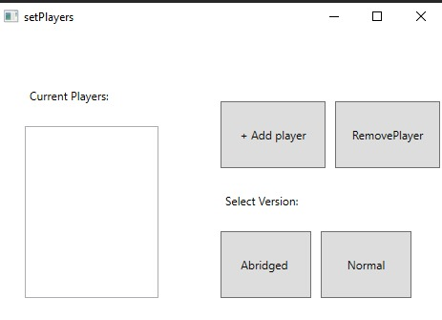

When you launch the game, you’ll be greeted by this screen. Here, you’ll add players by clicking “Add player” and remove them by clicking “Remove player”. Once you have added all players, you can select the abridged version that introduces a time limit and declares the player with the highest net worth the winner when time’s up, or the normal version that plays the game until only one player remains. Bare in mind, you need to add a minimum of 2 players or the game will not let you continue.

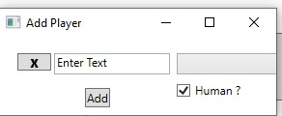

The player adding menu includes a text field to enter the player’s name, with a clear text button to the left of it. The dropdown menu specifies which token the player has, and the tick box specifies if they are human or a computer player.

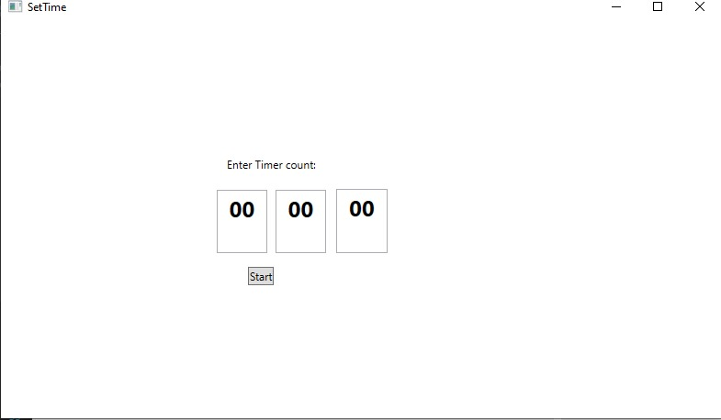

If you select the abridged version, you’ll be greeted with a row of text boxes to input the hours, minutes and seconds respectively that you wish the game to go on for. To play the game from here, press the start button.

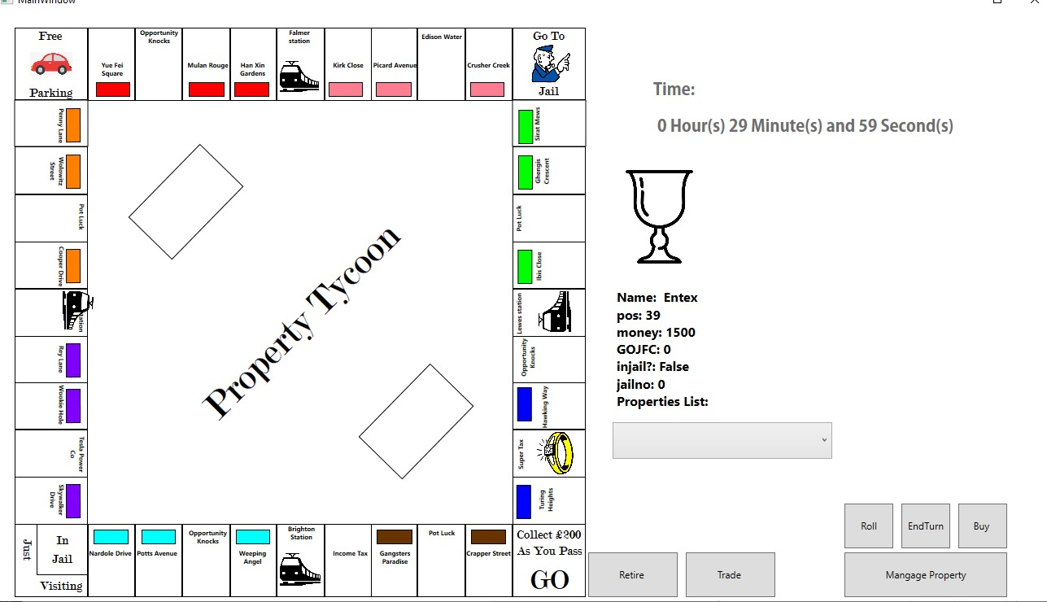

You’ll then have the main game interface displayed to you. This includes the game board, your token, and statistics and various buttons which will be gone into detail in a second. To access your properties, click the dropdown under your player stats. It is important to remember that all players play on the same screen and take turns. To end your turn, click the “End turn” button on the bottom right. To roll the dice, click the “roll button”. To buy a property you’re standing on, press the “Buy” button. To trade with another player, click “Trade”. To mortgage a property, click “Mortgage property”. To retire from the game altogether, click “Retire”. The time remaining in the game is also displayed above your token in the top right.